
SOP Title: | eComm Inventory Comparison Report
Document Storage Location: | STACS/Management/SOPs – Logistics and Warehousing | Document #: | SEASOP382v100
SOP Originator: | Kalishar Mitchell | Last Edited by: | Vslentina Popadic
Effective Date: | 6/11/2020 | Last Edited Date: | 12/21/2023
Other:

- Purpose
  - To provide documentation and comparison of Samsung and Third-Party inventory tracking and to ensure accuracy and coordinating inventory updates.
- Scope
  - Samsung eCommerce document and compare inventory counts from SAP and Synapse to ensure accurate inventory counts.
- Responsibilities
  - Samsung eCommerce team shall be responsible for ensuring that all counts are accurate to ensure precise operations.
- Instructions for Daily Stock Comparison Report
  - Pulling Daily Stock Comparison Report
    - NERP – ZRMMJ310470 Daily Stock Comparison Report
      - Fill in the following fields
        - Company – C310
        - Plant – S341
        - Storage Location – WC1E
        - Quantity Audit Date –Today’s Date (should be there by default)
        - Variant – /ECOMM
      - Save (F8)
  - 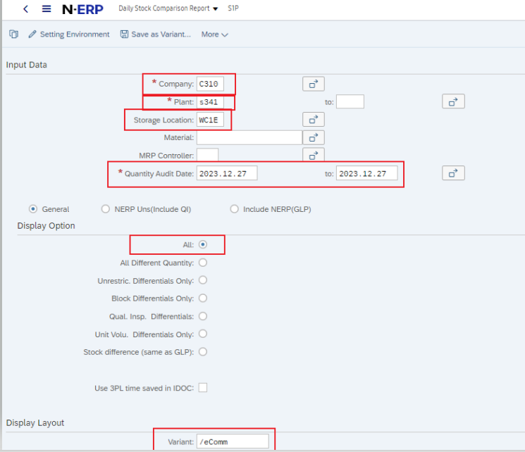

      - Export to Local File
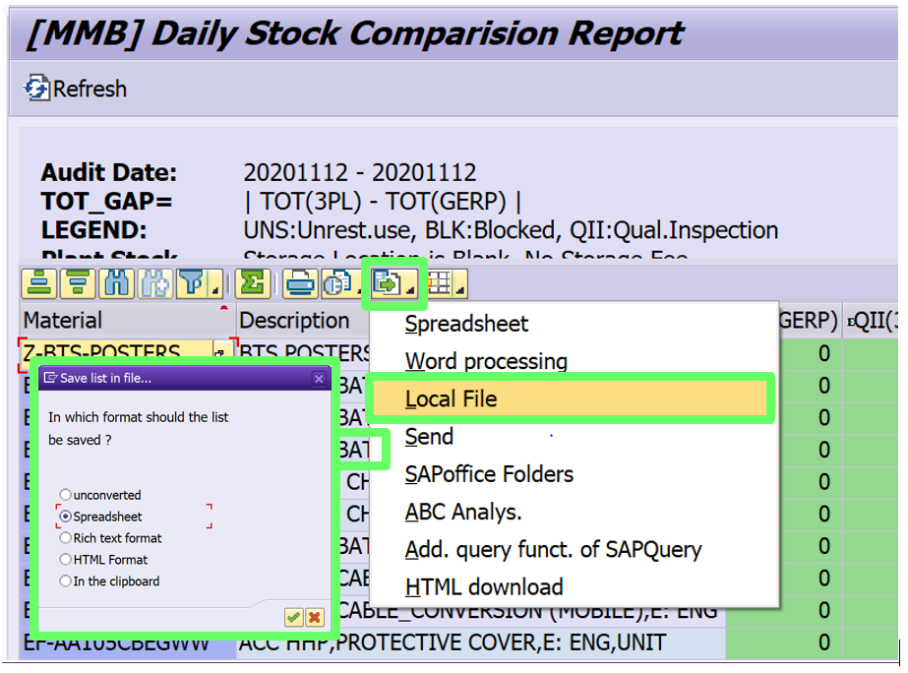

Note:
The GAP in the exported file is always positive. For this report we consider the GAP to be (GMP Stock) – (Synapse Stock).
Thus, If there is a 3PL stock overage GAP will be negative (-)
If there is a GMP stock overage GAP will be positive (+)
Ensure document is saved as .xlsx

  - Pulling the Moving Average Price (MAP)
    - GMP – ZRMDD02650 – Material Master List Display
      - Go to tab “Accounting / Costing”
      - Input the fields:
        - Material Code – SKU’s from SCR (the first column)
        - Plant – S341
        - Valuation Type – A
      - Execute (F8)
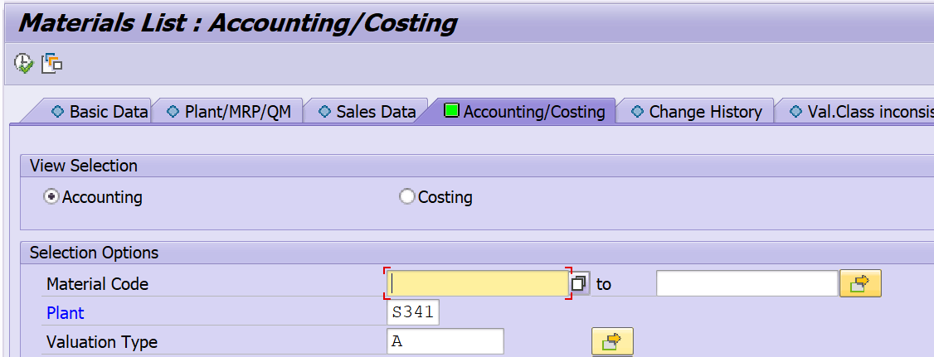

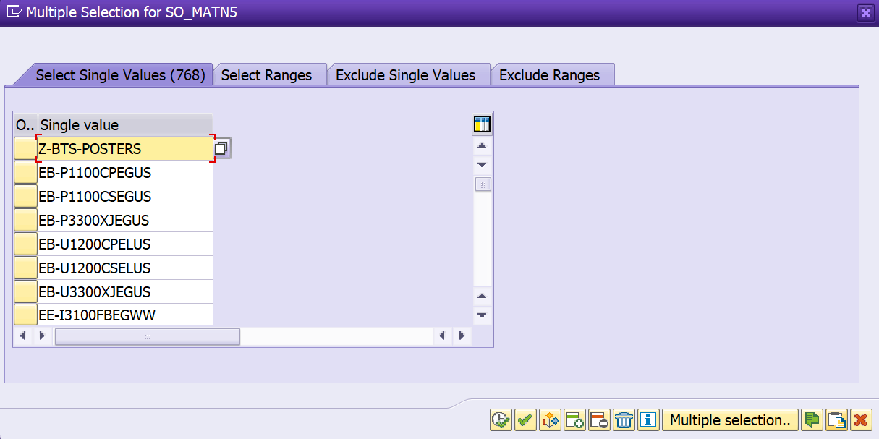

      - Scroll all the way to the bottom to allow the items to load
      - Highlight Material, Description, and MvAvgPrice column data by selecting each column header
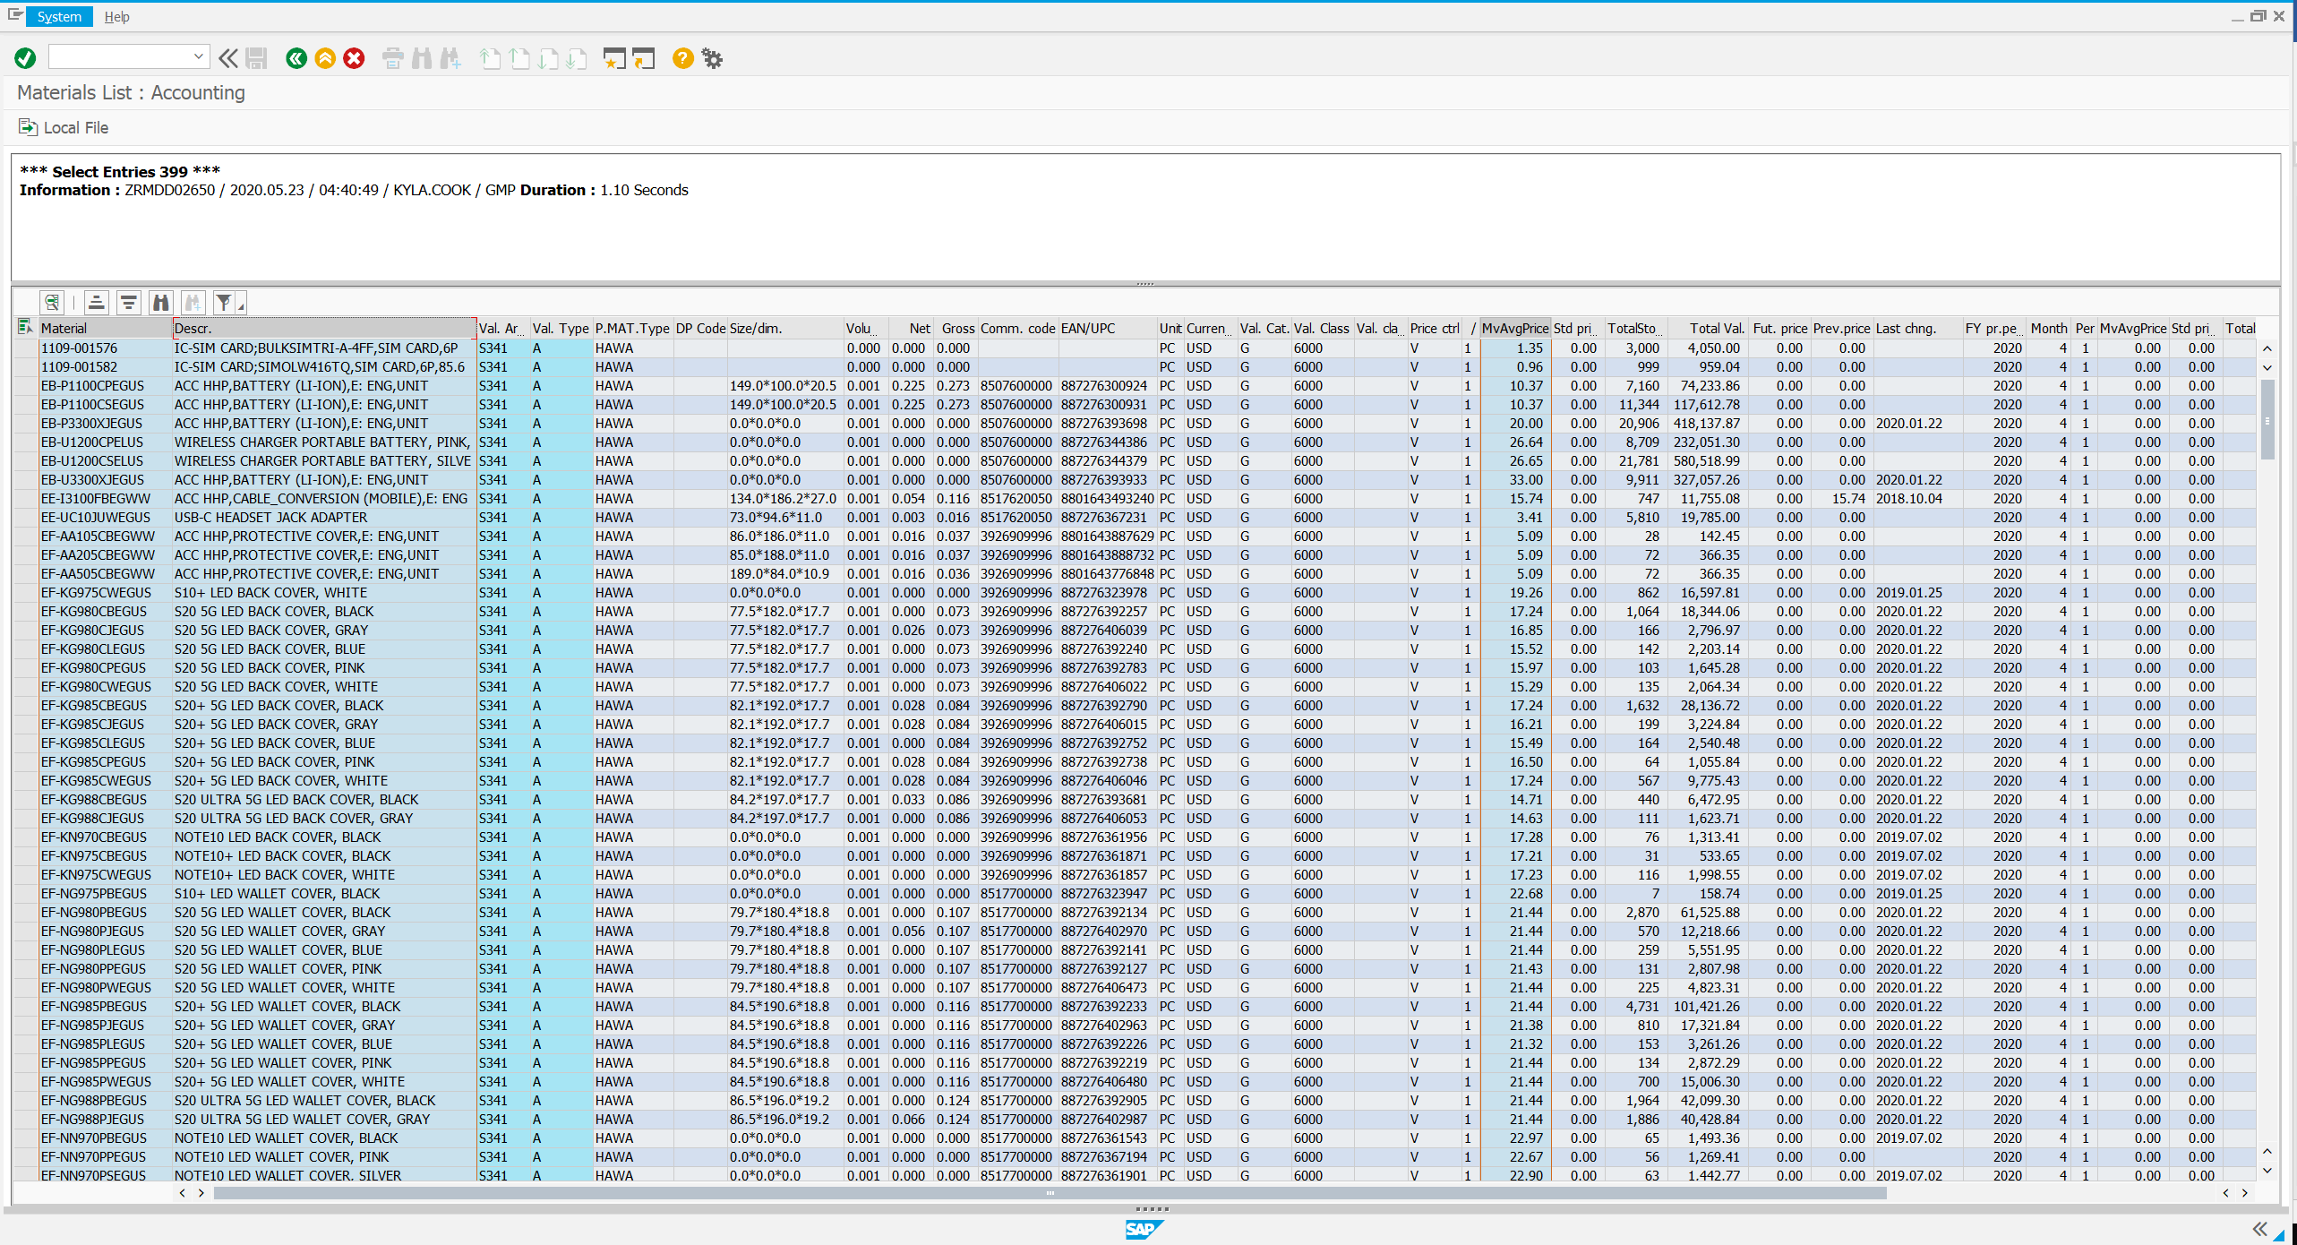
    - Copy and paste information from those 3 columns to Sheet 2 of exported Daily Stock Comparison Report
    - Rename “Sheet 2” tab to “MAP”
  - Producing Stock Comparison Report with Data
    - Under the “Net Gap” column take (“Total(GERP)”-“Total(3PL)”).
    - Under the MAP column use a vlookup formula to pull over the unit price for the material on each line.
    - Under “Absolute Cost” column add formula “=MAP*TotGAP”
      - Add the total for the “Absolute Cost” Column
    - Under the column “Net Cost” add formula “=MAP*Net GAP”
      - This is used to find the net gap cost of the discrepancy
      - Add a total for the total for the “Net Cost” column
    - Ensure Columns P and Q are formatted for currency $ with 2 decimal places
  - Distribute to the below groups:
    - eComm Team
    - Running List provided by previous sender
- Related Documents
  - [Example document]

